SMARTKNOWER – AI (MAJOR PROJECT)

(Sample output example)

When the code in this file is executed a StreamLit webapp page opens up where you can upload any picture that resembles either a dog or a cat and the backend program written on Google Colaboratory by me, will run the code and give you the output of whether the image uploaded is of a dog or a cat.

Here’s an example:

(Uploading a dog picture)   
Output Statement: “This image is most likely a Wooof! Wooof!”

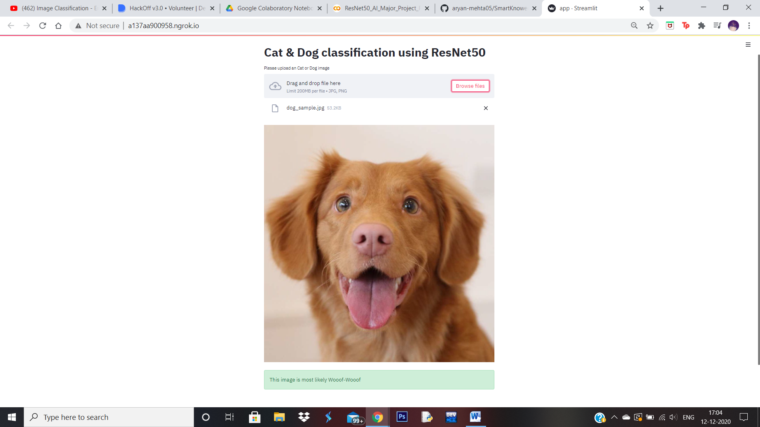

(Uploading a cat picture)  
Output Statement: “This image is most likely a Meow”

